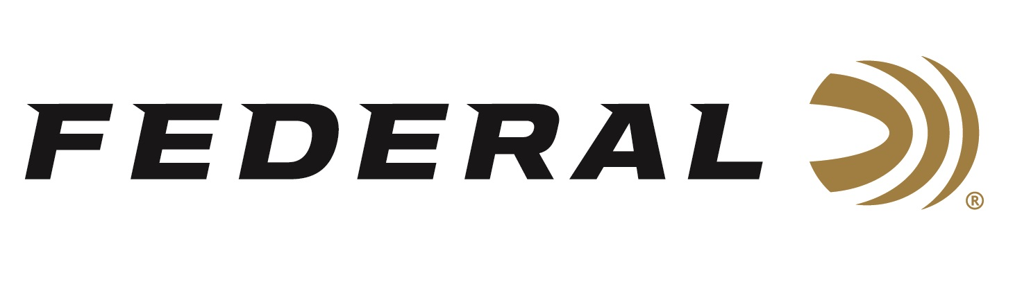

FOR IMMEDIATE RELEASE

**Team Federal Claims Sporting Clay Victories in Montana and Minnesota**

**ANOKA, Minnesota –** **August 26, 2025 –** Federal Ammunition congratulates sponsored shooters Cameron Hicks and Gregg Wolf for bringing home hardware at events in Montana and Minnesota. Hicks claimed High Over All in the FITASC event at the Western Challenge & Montana State in Three Forks, MT. Wolf finished as the Minnesota State Sporting Clay Champion at Hunts Point Gun Club in Pequot Lakes, MN. Both events concluded on August 24, 2025

At the Gallatin Sporting Clays venue in Three Forks, MT, Hicks claimed the FITASC event over 166 shooters by running the last 50 targets without a miss. Hicks finished the Main Event in fourth place.

For native Minnesotan Gregg Wolf, he finished the Minnesota State Championship as the top Sporting Clay shooter in Minnesota. In addition, the former World Champ also won the Super Sporting event and finished second in the Prelim, FITASC, and Hunts Point Cup events.

Federal Ammunition products, including the new Master Class, are available at dealers nationwide and online. This competition-level sporting clay load features a customized Podium wad that extracts peak performance from utilizing Federal’s straight-wall hull, reliable primers, high-antimony lead shot, and select propellant.

For more information on Master Class and all Federal products, visit [www.federalpremium.com](http://www.federalpremium.com).

**Press Release Contact:** JJ Reich

Senior Manager – Press Relations

E-mail: media@tkghunt.com

**About Federal Ammunition**

Federal, headquartered in Anoka, MN, is an ammunition brand of The Kinetic Group, owned by CSG, a globally diversified industrial group based in Prague (Czech Republic). From humble beginnings nestled among the lakes and woods of Minnesota, Federal Ammunition has evolved into one of the world's largest producers of sporting ammunition. In 1922, founding President Charles L. Horn paved the way for our success. Today, Federal carries on Horn's vision for quality products and services with the next generation of outdoorsmen and women. We maintain our position as experts in the science of ammunition production. Every day, Federal manufactures products to enhance our customers' shooting experience while partnering with the conservation organizations that protect and support our outdoor heritage. Federal offers thousands of options in our Federal Premium® and standard Federal® lines, which is what makes it the most complete ammunition company in the business and helps it provide customers with a choice no matter what the pursuit.